Workshop Report
Title of Program | Basic Life Support Hands-on Training
Objective of Program | To trained the students for CPR in case of emergency
Day and Date | 20/04/2023 & 21/04/2023 Thursday & Friday
Time | 2.00 to 5.00 pm
Speaker/Guest | Dr.Kanchan Honap
No. of Participants | 52
Convener | AESCOP
Coordinator/Program Commitee | Dr.Sanjivani Pise

Photos ( only 4)

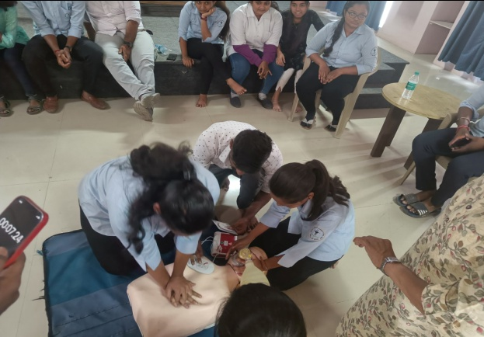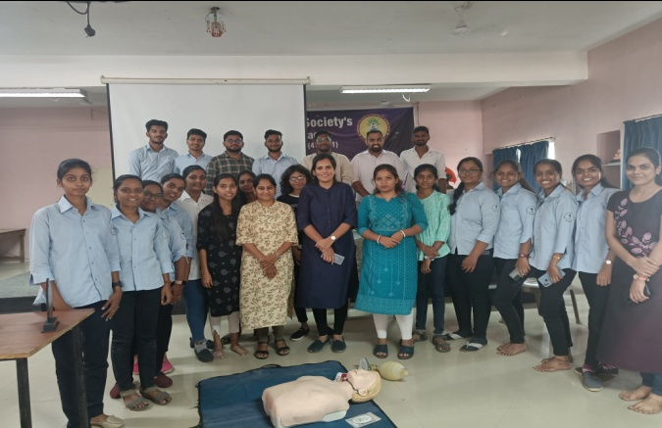

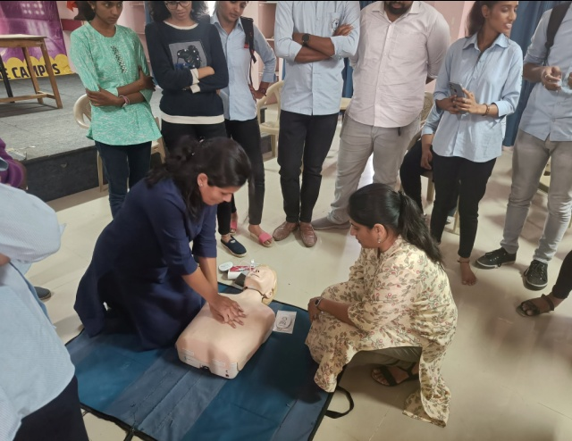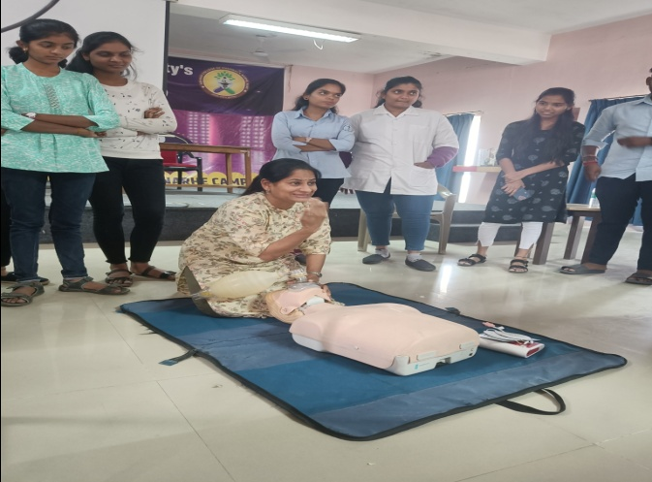

Detail Report:

Abhinav Education Society’s College of Pharmacy Narhe, Pune. Organized Two days workshop on Basic Life Support Hands-On training for the students of Pharm D, B.Pharm & Faculties 52 Students have participated in this program. This workshops aim was to aware students about basic life support like CPR(Cardiopulmonary Resuccitation) in case of emergency. For this Program Dr.Kanchan Honap from Sahyadri groups of Hospital was present as a trainer. This activity was conducted under the MoU with Sahyadri Groups of Hospital.

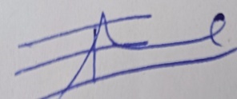
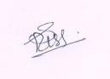

Coordinator Principal

