Workshop Report
Title of Program | CADD workshop
Objective of Program | To learn the new trends in Pharmaceutical Chemistry
Day and Date | Sunday 23rd April’23- Tuesday 25th April’23
Time | 9:30am -4:45pm
Speaker/Guest | Dr. Surya Pratap Singh
No. of Participants | 28 +two faculty members
Convener | Ms. Sharvari Chavan and Ms. Kumudini Pawar
Coordinator/Program Commitee | Ms. Sharvari Chavan and Ms. Kumudini Pawar

Photos

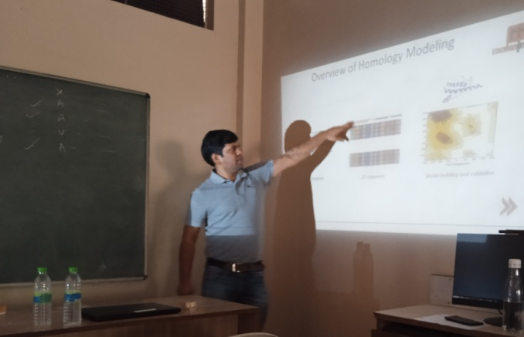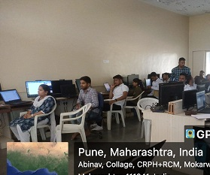

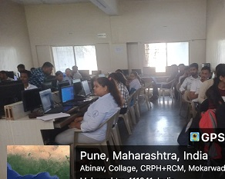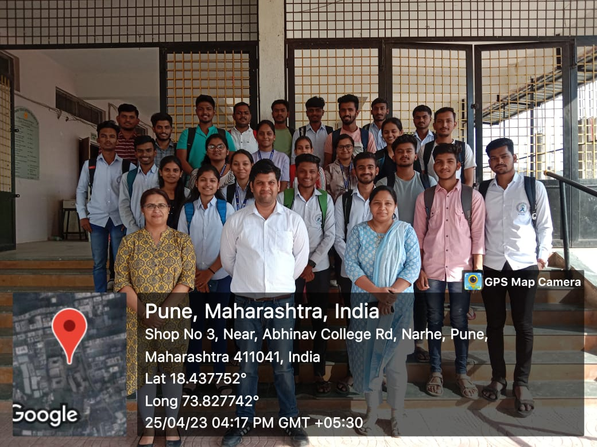

Detail Report:

CADD workshop was organized to update students as well as faculty to the new trends in Pharmaceutical Chemistry. It was a three day exhaustive workshop. Dr. Surya Pratap Singh was the resource person. He guided all the students on how to do docking, he also provided us with software required for docking.
Individually he assisted all our students and faculty in programming. Every day the session ended with question and answer session.
We are thankful to Dr. Surya Pratap Singh and we look forward to invite him again for guidance of our students in future.
.

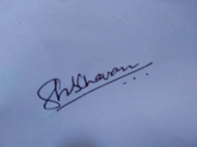

Training & Placement Head Principal

